Welcome To the Family!

Simple Temple and Family History Plan:

**Through small and simple invitations, we can build eternal families**

**and gather Israel on both sides of the veil.**

Purpose: help all participate in family history work and temple worship often and obtain blessings of divine protection, power, family closeness, and joy

The Ward Council develops the plan with consideration of needs and resources. Plan should identify actions to take during the year and determine how to implement the plan and make assignments accordingly.

Focus: to involve all including new/returning members/youth/children in family history work and specific members to prepare to receive temple ordinances utilizing the following specific measurable activities: 1) Members Submitting Names to the Temple, 2) First Four Generations of Ancestors in the Tree, 3) Members Logging In - [FamilySearch.org](http://familysearch.org/), 4) Members Participating in Family History Activities (Added Names to Tree, Added Memory to Tree, Indexed)

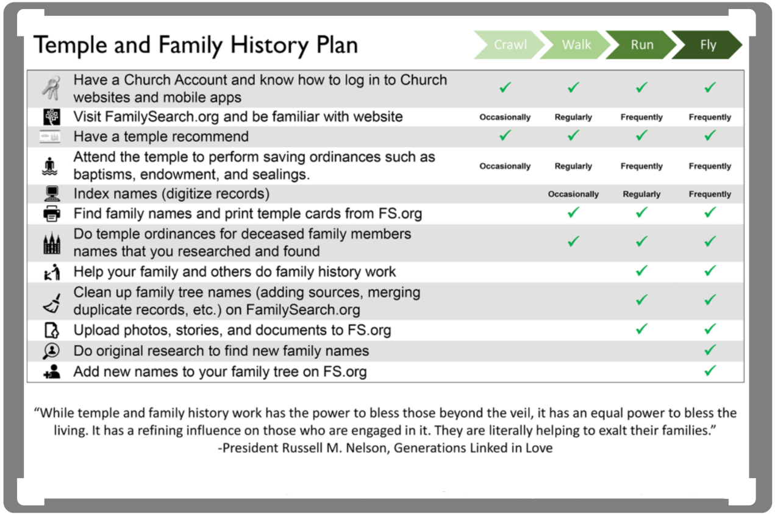

Ward Temple and Family History activities (Actions):

Hearts board: continue to encourage all to write an activity on a heart and place in on the temple

Ward Temple trip/combined activity once a month, tentatively 4th Friday

Youth Temple trips as possible—current goal for October 2021 if Sapporo temple becomes available or Tokyo once rededicated.

Quarterly special indexing challenge/Family History Seminar.

Temple and Family History Coordination Meetings: regularly—projected for 4th Sunday and open communication as needed.

Needs:

Temple Preparation Classes: as needed, next class projected as Chinese speaking focus

Ward council may help identify those that may be a focus for preparing a family Temple and Family History plan, preparing names, receiving ordinances, or may benefit from combined FHE or small group activity.

Ward Organizations may work with various consultants and leaders to help integrate Temple/Family History experiences and testimony sharing into planning and regular activities to possibly include sharing testimonies

Resources:

[ChurchofJesusChrist.org](https://www.churchofjesuschrist.org/bc/content/ldsorg/topics/my-family-booklet-pdf/english-whole-pdf.pdf) The My Family booklet downloaded or purchase pamphlets

See Featured Family History Videos:

<https://www.churchofjesuschrist.org/topics/family-history/videos?lang=eng>

Familysearch.org ([www.familysearch.org](http://www.familysearch.org)) and The [FamilySearch Tree app](http://www.familysearch.org/blog/en/mobile) and [FamilySearch Memories app](http://www.familysearch.org/blog/en/mobile) for mobile devices

For partner access to various resources like To Ancestry.com, find my past, My Heritage, American Ancestors, Filae, and Geneanet see <https://www.familysearch.org/campaign/partneraccess/>

<https://www.facebook.com/familysearch/> <https://www.pinterest.com/familysearch/pins/>

Rootstech

<https://www.familysearch.org/rootstech/rtc2021/search>

Stake activities/guidance

Tokyo Temple originally dedicated 27 Oct 1980 by Pres. Spencer W. Kimball making it the first temple in Asia. https://www.churchofjesuschrist.org/temples/details/tokyo-japan-temple/prayer/1980-10-27